SMART ASSISTIVE SHOE FOR VISUALLY IMPAIRED PEOPLE

Team Name: “KNS”

Tagline: Step with Confidence – Smart Navigation for Independent Mobility

Project Type:
Embedded System-Based Wearable Device

Category:
Health, Life and Human Safety.

Chapter 1

PROBLEM STATEMENT
Visually impaired individuals face significant challenges when navigating unfamiliar or dynamic environments, often leading to anxiety and reduced independence. Current assistive devices have critical limitations, leaving users vulnerable to unseen obstacles and disorientation.


Inadequate Obstacle Detection
Traditional white canes only detect ground-level obstacles, failing to warn of overhead hazards or complex environmental features.

High Cost 6 Limited Access

Guide dogs offer excellent assistance but are prohibitively expensive to train and maintain, making them inaccessible to many.

Lack of Real-Time Awareness

Existing aids often lack the ability to provide real-time spatial awareness, leading to collisions, disorientation, and a dependency on others.

Chapter 2

Introducing the Smart Assistive Shoe
Our innovative solution is a smart assistive shoe designed to provide visually impaired individuals with real-time sensory feedback, enhancing their ability to navigate independently and safely.

Integrated Ultrasonic Sensor
Accurately detects obstacle distances in the user's path, both at ground level and overhead, providing crucial spatial information.

Intuitive Haptic Feedback
A vibration motor delivers clear, directional alerts, allowing users to intuitively perceive proximity to obstacles without auditory overload.

Auditory Alerts
A buzzer provides supplemental audible warnings, particularly useful for alerting to immediate or critical hazards.

Motion 6 Stability Monitoring
An IMU sensor tracks motion and stability, offering insights into gait and balance, further contributing to user confidence and fall prevention.

Sustainable Power Generation
Piezoelectric pads embedded in the sole generate energy during walking, offering a self-sustaining power source that reduces the need for frequent charging.

Chapter 3

Intelligent System Architecture
The smart assistive shoe operates as an embedded, offline system, ensuring reliability and responsiveness without reliance on external connectivity.


Sensor Scan
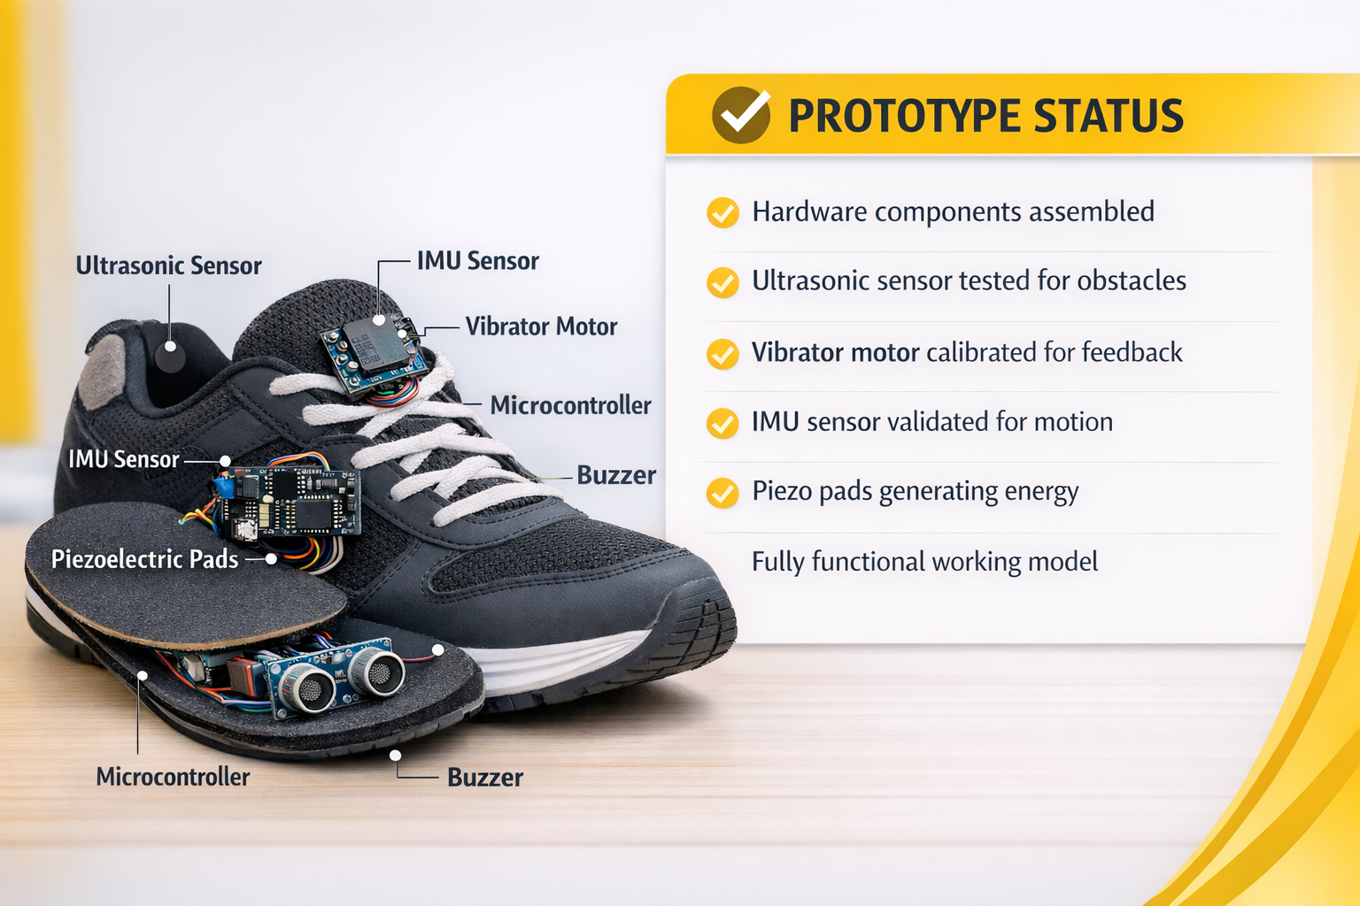
Ultrasonic scans surroundings


Data Processing
Microcontroller computes distance


Haptic 6 Alert
Vibration and buzzer respond


Motion 6 Power
IMU tracks; piezo powers MCU

Chapter 4

Key Components: Hardware 6 Software
The shoe's functionality is powered by a combination of robust hardware and efficiently programmed software, designed for optimal performance in a wearable device.

Hardware Innovations
Microcontroller: The central processing unit, executing all embedded logic.
Ultrasonic Sensor: For precise, non-contact distance measurement of obstacles.
Vibration Motor: Provides tactile feedback for intuitive navigation cues.
Buzzer: Delivers auditory alerts for immediate attention.
IMU Sensor: Tracks orientation, motion, and stability of the user's foot.
Piezoelectric Modules: Harvest kinetic energy from walking, extending battery life.

Software Intelligence
Embedded Programming Logic: Optimized code for efficient, real-time operation on the microcontroller.
Distance-Based Alert Algorithms: Sophisticated algorithms that translate sensor data into clear, actionable feedback for the user.
Power Management Routines: Software that intelligently manages energy consumption and utilization of harvested power.
Calibration & Self-Correction: Routines to ensure sensor accuracy and adapt to varying environmental conditions.

Chapter 5

Prototype Development Status
We have successfully developed a functional prototype that demonstrates the core capabilities of the smart assistive shoe. All critical components have been integrated and individually verified.
3
Haptic Feedback
Vibration motor calibrated to
provide clear and discernible feedback based on proximity.
1
Hardware Assembly
All physical components have been successfully assembled and integrated into a wearable form
factor.
2
Obstacle Detection
Tested and validated the accuracy
and range of the ultrasonic sensor for various obstacle types.
4
Auditory Alerts
Buzzer alerts validated for timely and effective warning signals.
5
Energy Generation
Piezoelectric pads tested for efficiency in converting kinetic energy into electrical power.

Chapter 6

Comprehensive Feasibility Analysis
Our smart assistive shoe project demonstrates strong feasibility across multiple critical dimensions, promising a viable and impactful solution for visually impaired individuals.

Technical
Low-power embedded system design ensures long battery life and reliable performance in a compact form factor.

Social
Significantly enhances independence, confidence, and safety for visually impaired individuals, improving quality of
life.

Economic

Estimated cost of ₹1300–₹1600 makes the device highly affordable and accessible to a broad user base.

Operational
Intuitive vibration-based alerts and a user-friendly design ensure ease of adoption and daily use.

Practical
Compact, wearable design integrated directly into footwear offers discreet and comfortable assistance.

Chapter 7

Execution Roadmap
A phased approach will guide the development, testing, and deployment of the smart assistive shoe, ensuring thorough validation and optimization at each stage.

Phase 1: Design 6 Prototyping
Detailed design of hardware and software architecture, component selection, and initial prototype fabrication.

Phase 2: Assembly 6 Integration
Precision assembly of all components and seamless integration of hardware and software elements.

Phase 3: Rigorous Testing
Comprehensive testing of all functionalities, including sensor accuracy, feedback mechanisms, and power efficiency.

Phase 4: User Trials 6 Feedback
Pilot trials with visually impaired users to gather real-world feedback and assess usability in diverse environments.

Phase 5: Optimization 6 Refinement
Iterative improvements based on user feedback and testing results to enhance performance, comfort, and reliability.

Chapter 8

Cost Estimation
Our design prioritizes affordability to ensure widespread accessibility, making advanced assistive technology available to those who need it most.

Approximate Total Cost:
Microcontroller
₹200-₹300
Ultrasonic Sensor
₹150-₹200
Miscellaneous
₹20-₹100
₹1300–₹1600
This cost-effective solution makes advanced mobility assistance accessible to a wider demographic, aligning with our mission of inclusive technology.
Vibration Motor  ₹50-₹80 | Buzzer  ₹30-₹50
IMU Sensor  ₹250-₹350 | Piezoelectric Modules  ₹400-₹500

The economic viability of our smart shoe is a cornerstone of its potential impact.
By leveraging readily available components and efficient design, we aim to deliver a high-value product at a low cost.

Empowering Mobility Through Smart Technology

Thank you for your attention and support in advancing independent mobility.

